A PROJECT PROPOSAL

ON

**“ONLINE STREAMING PLATFORM”**

**Group Name:** Diagon_Alley

**Group Members:**

1. Md. Rashadul Islam (19202103169)
2. Md. Faysal Mahmud (19202103174)
3. Sadia Sultana (19202103184)
4. Latiful Islam Shoishob (19202103162)
5. Dipa Rani (19202103201)

Project Proposal - **Online Streaming Platform**

1. **Introduction:**

Streaming Media may be defined as listening or viewing media in real time as it comes across

the World Wide Web. With streaming technology, users can watch and listen to media while

it is being sent to their browser, instead of waiting for it to completely download and then playing it.

**1.1 System Description**

**” Cine Bilash ”** is an online video streaming platform. **” Cine Bilash ”** offers a bunch collection

of movies, web series and so on across 5 languages. Highly evolved video streaming technology

and a high attention to quality of experience across devices and platforms which will make the

customers encourage smooth experience on Online streaming Platform.

1. **Background Of the Project:**

Online streaming platforms have become increasingly popular over the years, with the likes of Netflix, Hulu, and Amazon Prime Video dominating the market. Chorki, Bongo, Bioscope, Toffee also dominate the Bangladeshi marketplace nowadays. These platforms have revolutionized the way we consume video content, providing users with the ability to watch their favorite movies and TV shows on-demand and at their convenience. According to Statista, the number of video streaming users worldwide is expected to reach 1.1 billion in 2021, which represents a massive growth opportunity for the streaming industry.

WordPress is one of the most popular content management systems (CMS) in the world, powering over 39% of all websites on the internet. WordPress provides a robust and flexible platform for building websites and managing content, making it an ideal choice for building an online streaming platform.

1. **Motivation**

Basically after using Chorki, Disney plus, Netflix and so on we found out few problems as like

- buffering issue, No preview system, country restriction and so on. We decided why not make

a platform where the user gets almost everything that is needed.

That is why we decided to work on this project. Improving **few things as like -**

• more than 5 language based movies, web-series etc.

• low cost subscription

• Preview system before Registration

• Genre based specific Movies, Web-Series Categories & Sub-categories

• easy to use & handle

• no country restriction

1. **Objective**

* To give a smooth video streaming experience
* To give users a proper medium to entertain
* Giving a preview to the users before registration
* User Friendly interface and very low cost subscription
* 24/7 customer support

1. **Users of This Project:**

* **User -** Free & Paid
* **Admin -** To Control

1. **ER- Diagram:**

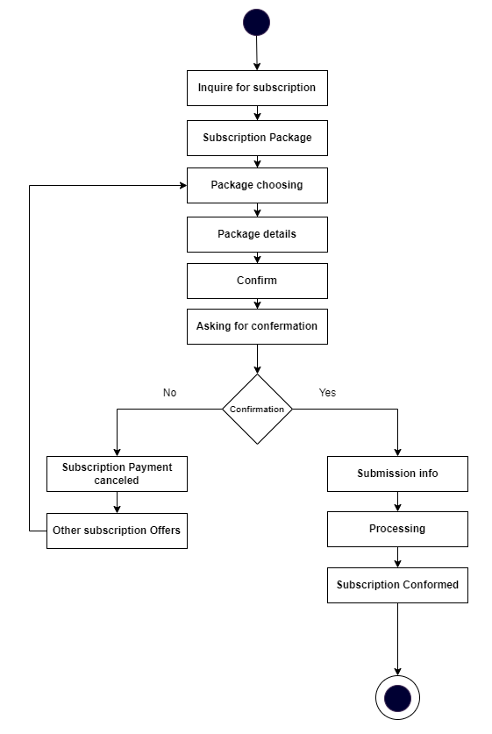

1. **Project Features and Outcomes:**

Why do users choose our site? Of course, we need to give them some extra benefits which

encourage users to come and use our site. Some of our advantages -

* Trailer Preview before registration
* 24/7 customer service
* Low cost subscription
* Higher quality video streaming
* Less buffering
* Top reviews by the users (movies , web-series & drama categories) available
* Category wise movie, web-series etc. available